**LAPORAN PRAKTIKUM**

Nama : Maftuchati

NIM : 18090015

Kelas : 5B

**PRAKTIKUM 4**

1. Source Code

* Web.php => application/controller

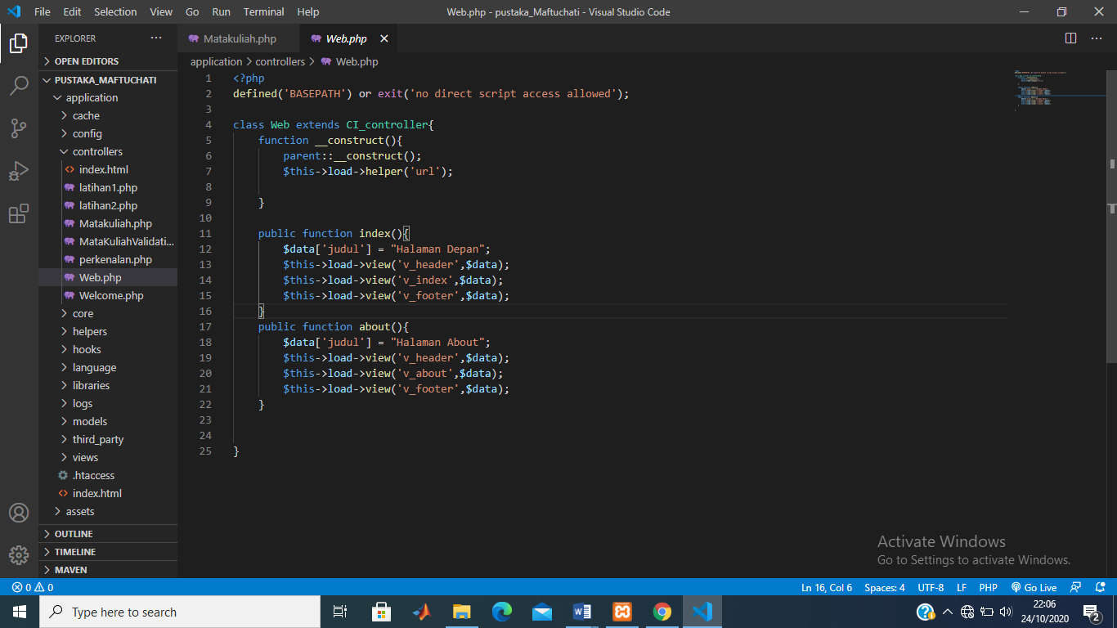

* v_header.php => application/view

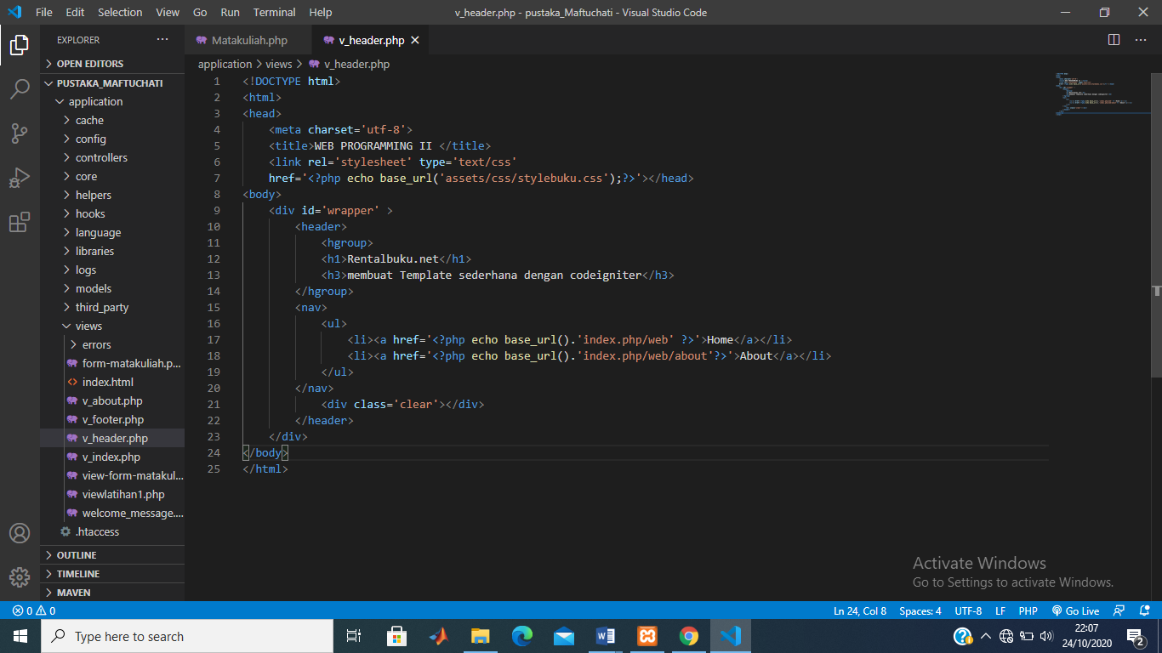

* v_index.php => application/view

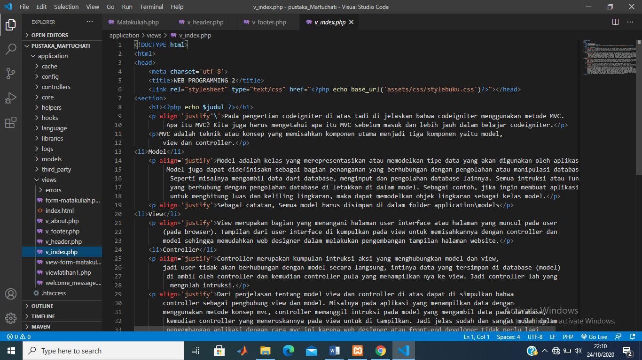

* v_footer.php = > application/view

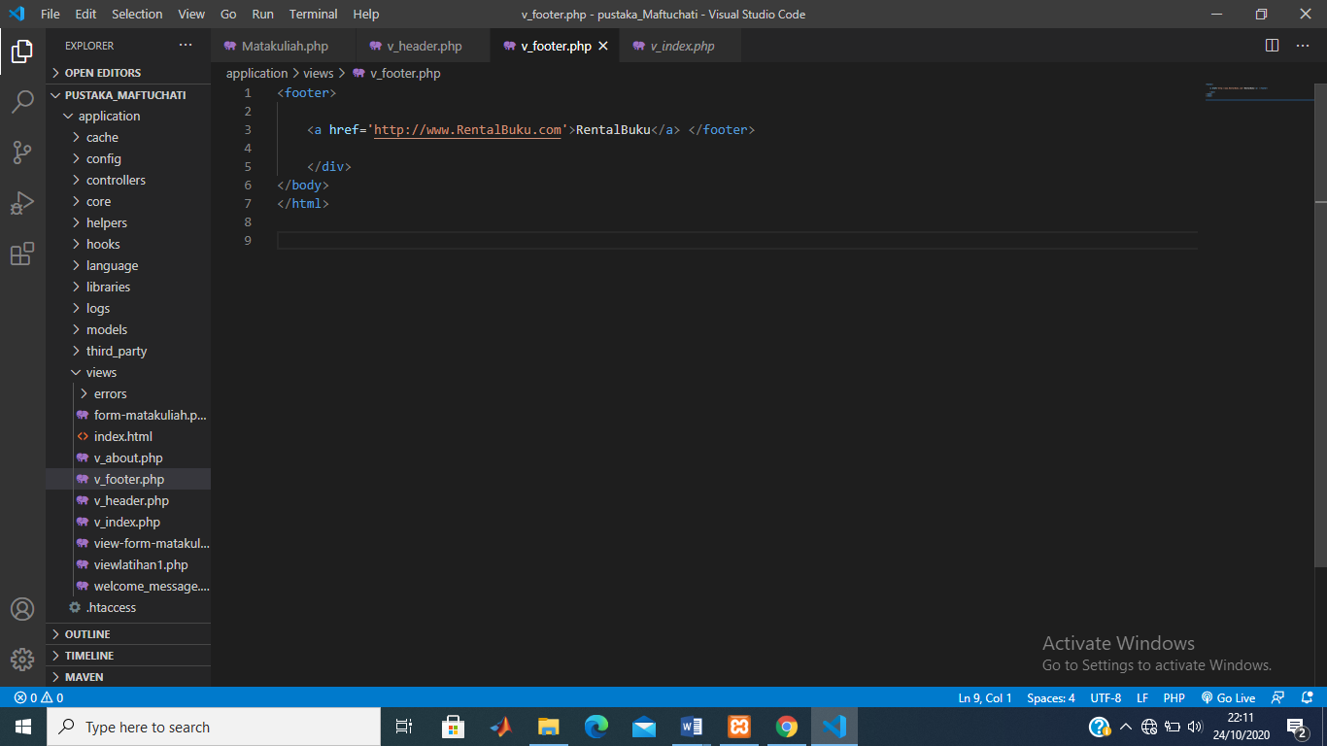

* v_about.php => application/view

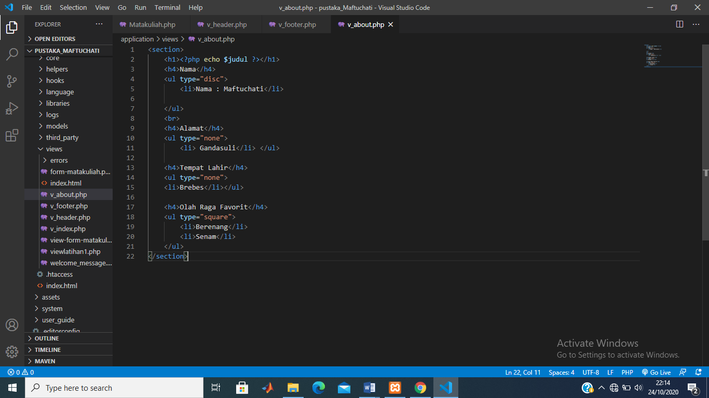

* stylebuku.css => assets/css

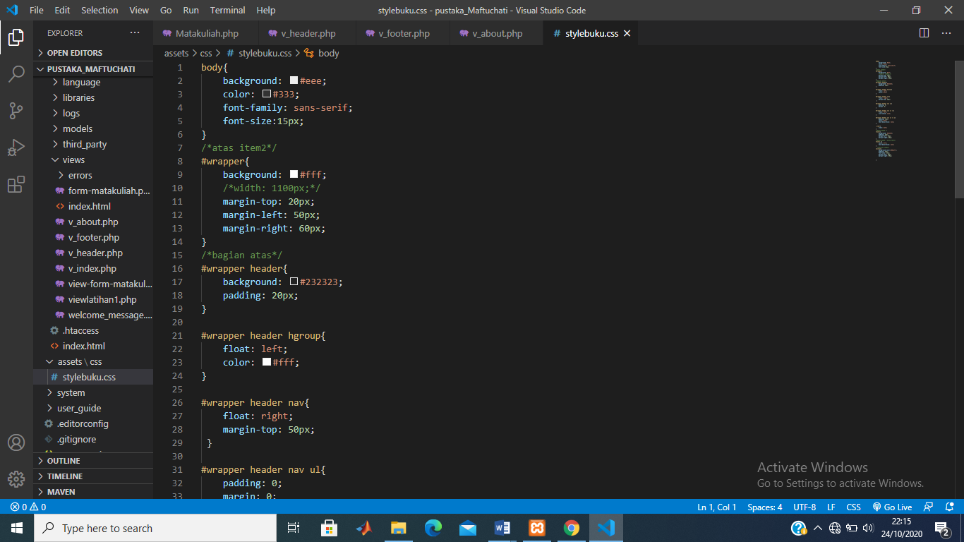

* config.php => application / config

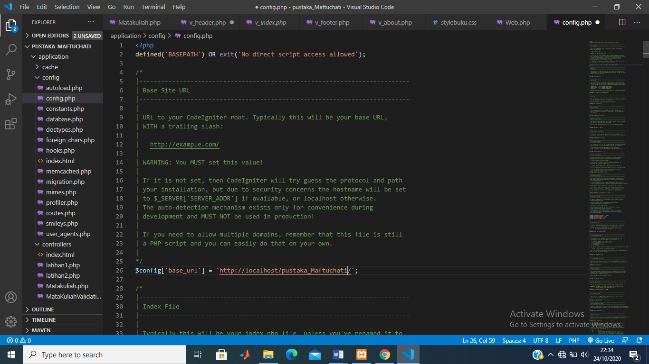

* autoload.php => application / config

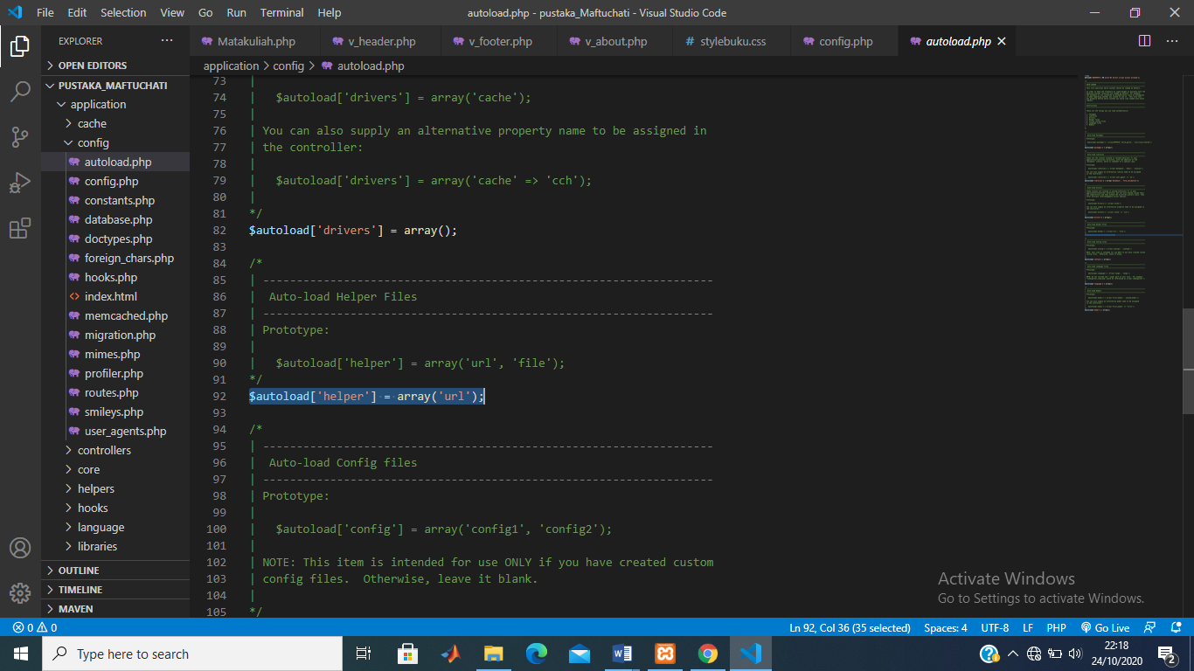

1. URL

<http://localhost/pustaka_Maftuchati/index.php/web>

<http://localhost/pustaka_Maftuchati/index.php/web/about>

1. Capture Hasil

* Home

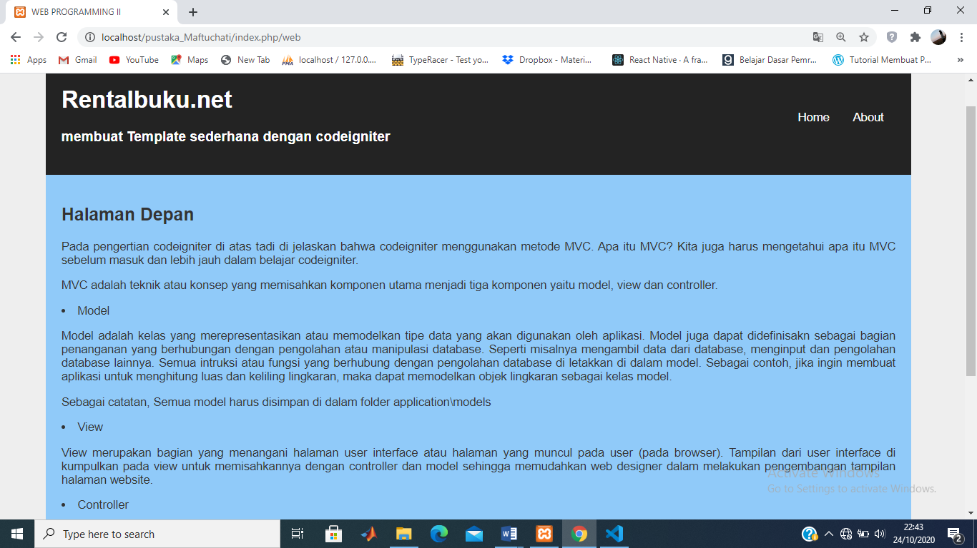

* About

